***Lab 2 (Operating System) CS191092 4B1 Poorab Gangwani***

1. Which command is used to display complete date and time?

Ans) date

1. Which command is used to assign the following permissions to a newly created file.

· No permission to others = chmod o-rwx filename

· All permissions to owner = chmod u+rwx filename

· Read and Write permissions to group = g+rw filename

1. Create three text files namely file1, file2 and file3 and write some text in those files. Next, concatenate file1 and file2 with file3. Lastly, count the total number of words and lines in the file file3

Text in file 1

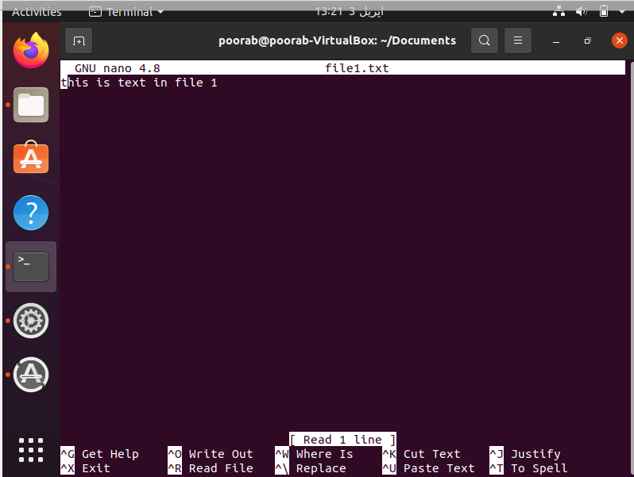

Text in file 2

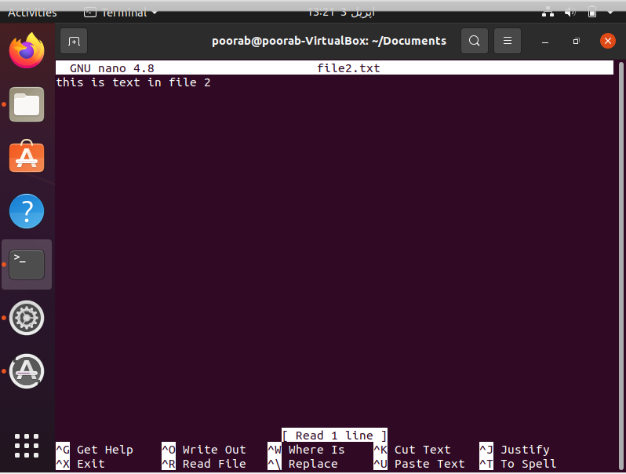

Text in file 3

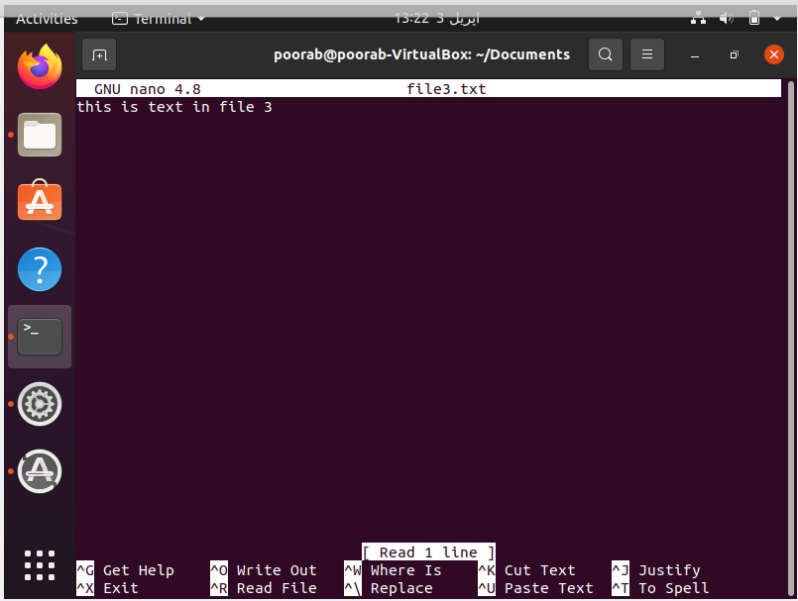

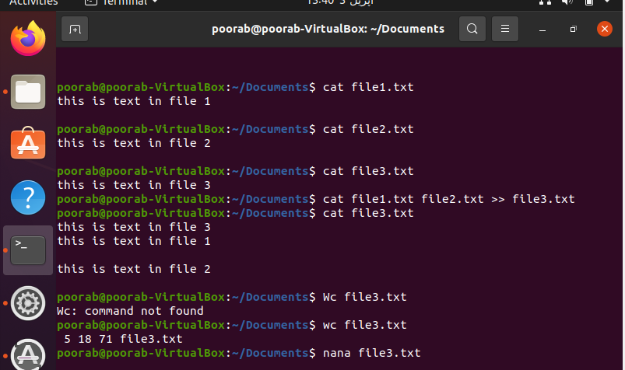

4. What is the command used for getting the time and date at which the System was last booted up?

Ans) who -b

5. Which command displays the name and number of total users logged in?

Ans) who –q

6.

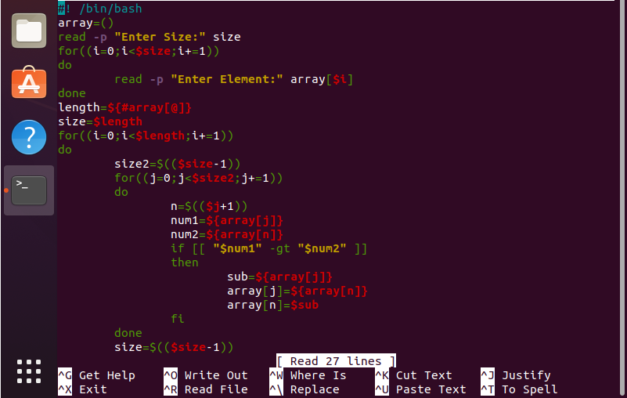

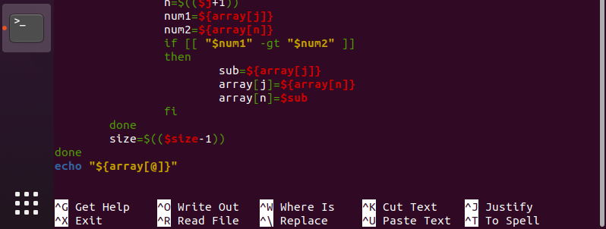

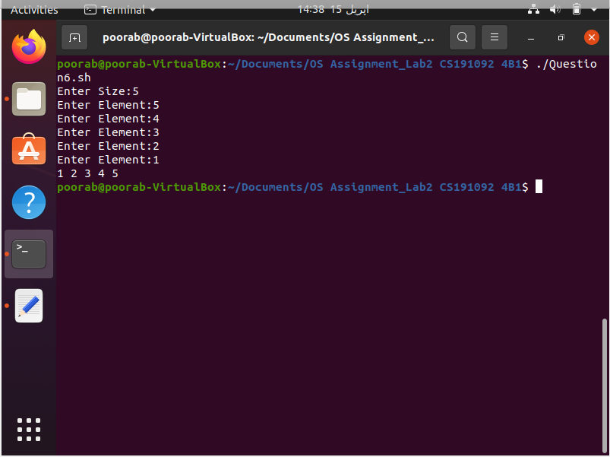

7)

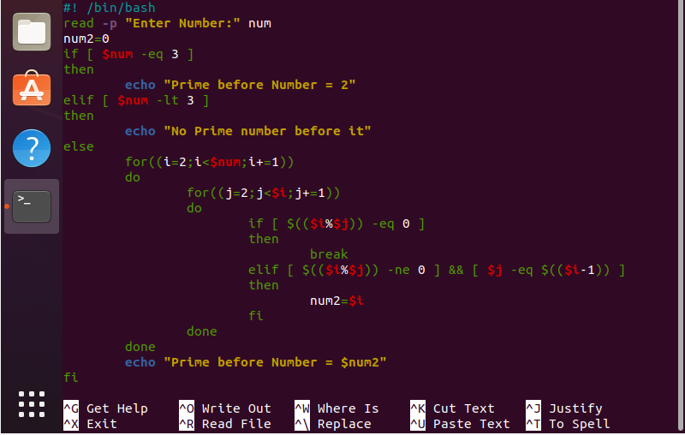

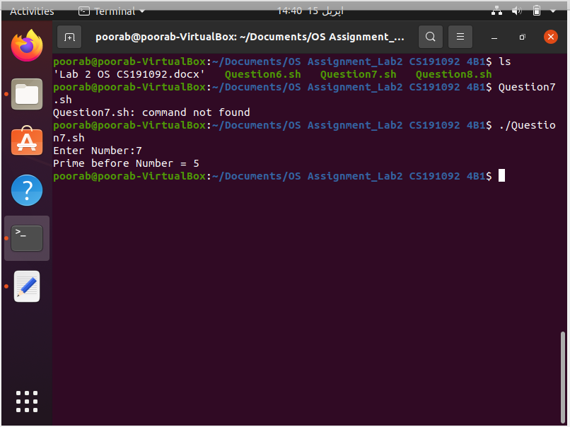

8)

